REPORT FOR DEGREE DETECTIVE:

As project of class assignment:-

Under the Guidance of:

Dr. Ranjith Kumar(26108)

Project members:

Prabhat Sharma--12109008

Adarsh Kumar--12104303

Daresh Kumar sah—12104224

Submitted By:

Name :- Daresh Kumar Sah

Reg No :-12104224

School :- School of Computer Science and Engineering

Name of University :- Lovely Professional University.

Course Code: CSE310

Date of Submission :- April 20



Declaration:-

We hereby declare that the project work entitled “The Temperature Convertor” is an authentic record of our own work carried out as requirements of Java Project for the award of B.Tech degree in P132: B.Tech(Computer Science and Engineering) from Lovely Professional University, Phagwara, Punjab under the guidance of Dr.Ranjith Kumar(26108). All the information furnished in this Java project report is based on our own intensive work and is genuine.

**Name of the Student :**

Daresh Kumar Sah

Registration no: 12104224

Contents:

**1.INTRODUCTION…………………………………………**

1.1.Unit of Temperature………………………………………

1.2.Formula for Temperature scale…………………………

1.3.Scope of Project…………………………………………………

1.4.System Overview………………………………………………

**2.Modules……………………………………………………………..**

**3.Design…………………………………………………………………**

3.1.Source of project……………………………………………

3.2.Screenshot………………………………………………………

3.3.Explanation………………………………………………………

3.4.E-R Diagram…………………………………………………….

**4.Sample Code…………………………………………………………**

4.1.GUI design…………………………………………………………

**5.Outcome of Project……………………………………………….**

**6.Conclusion…………………………………………………………….**

TABLE:

|  |  |  |
| --- | --- | --- |
| Sn. | Content Name | Page no. |
| 1 | Introduction | 04 |
| 2 | Scope of Project | 05 |
| 3 | Modules | 06-09 |
| 4 | Design, Screenshot and Explanation | 10-12 |
| 5 | Sample code | 13-15 |
| 6 | Outcome of project | 15-16 |

**INTRODUCTION**

A temperature converter helps in the conversion of the measurement units of the temperature recorded in a particular unit. Temperature expresses the degree of heat or cold of a solid, liquid, or gas. Temperature is measured using a thermometer. While Kelvin (K) is the SI unit of temperature, people generally use Centigrade or Celsius (°C) and Fahrenheit (°F) to measure temperature.

For example, the lowest practical temperature on Earth is -273.15 degrees Celsius. Celsius is a measure of temperature. This recording can be represented in Kelvin as 0 K. We use temperature converter to find the different readings of a given temperature on different unit measuring scales.

**UNIT OF TEMPERATURE**

Different units can be used to record the temperature. The three different units used for measuring temperature are Celsius (°C) Fahrenheit (°F),  and Kelvin (K).  Kelvin is the SI unit of measuring temperature, whereas Fahrenheit and Celsius are commonly used scales.

**Formula For converting temperature Scales**

Temperature reading given in one unit can be converted into the other using certain conversion formulas. These conversion formulas can be studied as,

* Celsius to Fahrenheit Conversion
* Fahrenheit to Celsius Conversion
* Celsius to Kelvin Conversion
* Fahrenheit to Kelvin Conversion

**Formula**

* Celsius to Fahrenheit: C->F

F= [9/5*C]+32

* Fahrenheit to Celsius: F->C

C=[5/9]*(F-32)

* Kelvin to Celsius: K->C

C=K-273

* Celsius to Kelvin: C->K 🡪 K=C+273.15

**Scope of Project**

The scope of a temperature converter project typically involves designing and developing a software application or tool that can convert temperature measurements from one scale to another. The main objective of the project is to create a user-friendly interface that allows users to easily convert temperature values between Celsius, Fahrenheit, and Kelvin scales.

The project scope may include the following components:

* 1. User interface design: The project should have a simple and intuitive interface that allows users to enter the temperature value and select the input and output scales.
  2. Temperature conversion algorithm: The project should include an algorithm to convert temperature values from one scale to another. The algorithm should be accurate and efficient.
  3. Error handling: The project should include error handling mechanisms to ensure that the user inputs valid temperature values and selects valid input and output scales.
  4. Unit testing: The project should include a set of unit tests to verify the correctness of the conversion algorithm and error handling mechanisms.
  5. Deployment: The project should be deployed to a suitable platform, such as a web server or a mobile application store, to make it accessible to users.

The scope of the project can be expanded to include additional features, such as support for other temperature scales, historical temperature data, or integration with other applications.

**System Overview:**

Temperature is the measure of hotness or coldness expressed in terms of any of several scales, including Fahrenheit and Celsius. Temperature indicates the direction in which heat energy will spontaneously flow—i.e., from a hotter body (one at a higher temperature) to a colder body (one at a lower temperature).

**Modulus:**

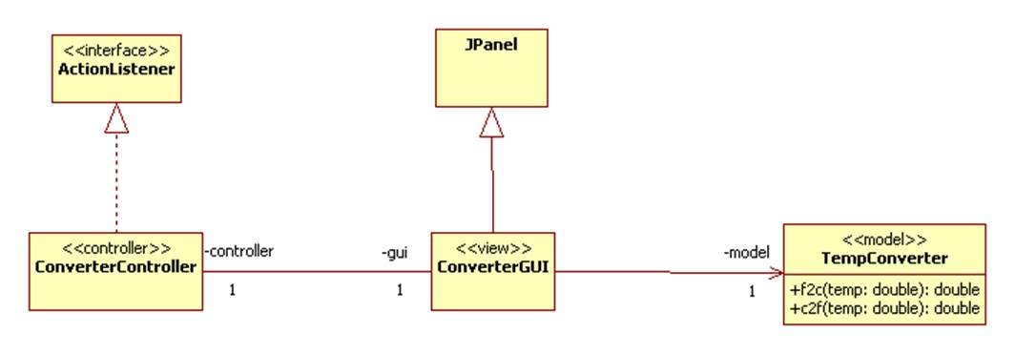

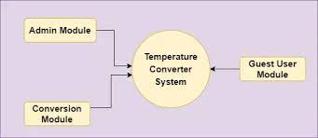

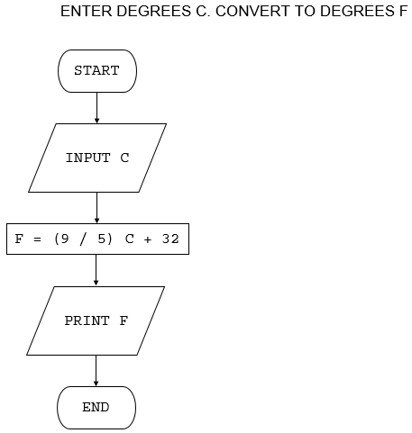

**Celsius** **Converter ( °C ⇒** °F or K **):**

This function will only convert the Celsius temperature value into Fahrenheit or Kelvin. So whenever the user enters a °C value.

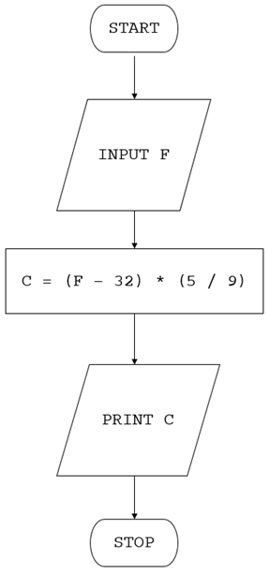

**Kelvin** **Converter ( K ⇒** °F or °C **):-**

This function will only convert Kelvin temperature value into Fahrenheit or Celsius. When a user enters a K value.

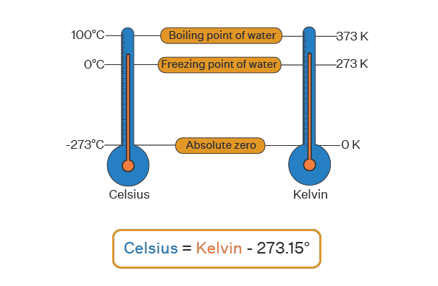

**Design**

**Source of Project:**

Decide on the input and output format: Determine the input and output format you want for your temperature conversion project. For example, you might want to accept input in Celsius and output in Fahrenheit, or vice versa.

Write the conversion formula: Research the formula to convert temperatures between the two units you've chosen. For example, to convert Celsius to Fahrenheit, the formula is: (Celsius * 1.8) + 32 = Fahrenheit.

Code the conversion function: Write a function that accepts the input temperature and applies the conversion formula to produce the output temperature.

Add user input: Create a user interface that prompts the user for input and displays the output.

**Screenshot:**

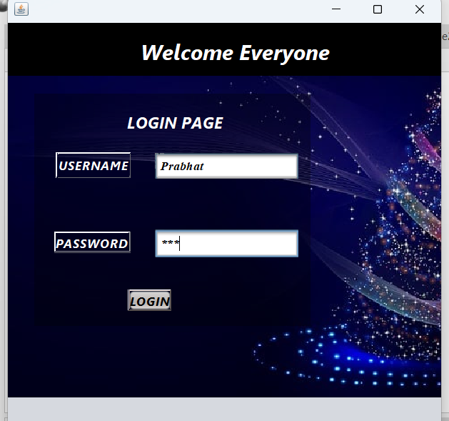



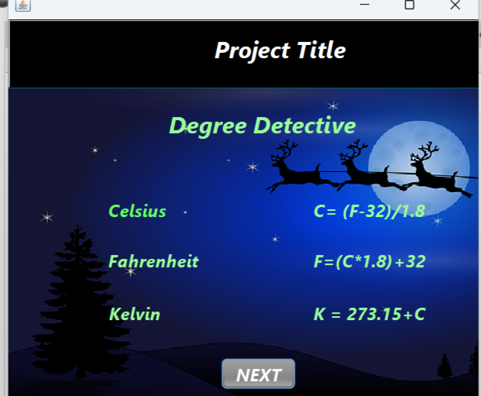

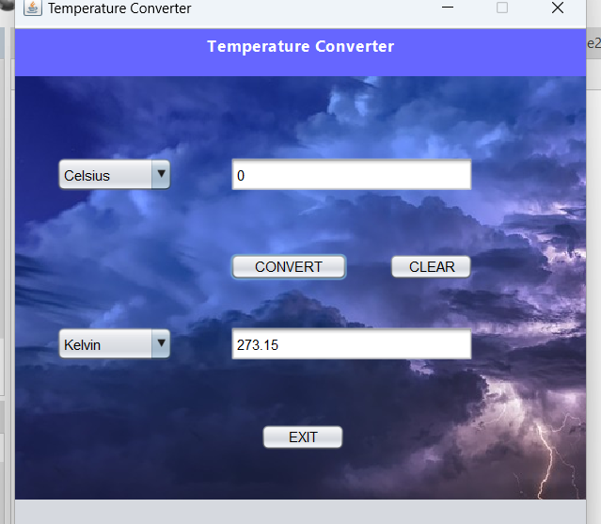

**Explanation:**

The Project “Degree Detective” consists of 4 phases :

1. **LOGIN PAGE**
2. **PROJECT MEMBERS DETAILS**
3. **PROJECT TITLE**
4. **TEMPERATURE CONVERSION**

The first jframe consists of login page simply ask the user to enter the username and password to further get in.

The second Jframe consists of project member details who were involved in this project .

The third Jframe contains Project title “Degree Detective” and the formula that has been used to write the logic and code.

The fouth frame contains the main temperature conversion page where all the conversion is going to happen. The values that user puts in Degree Celsius will be converted to Fahreinheit or Kelvin and vice-versa.

E-R diagram:

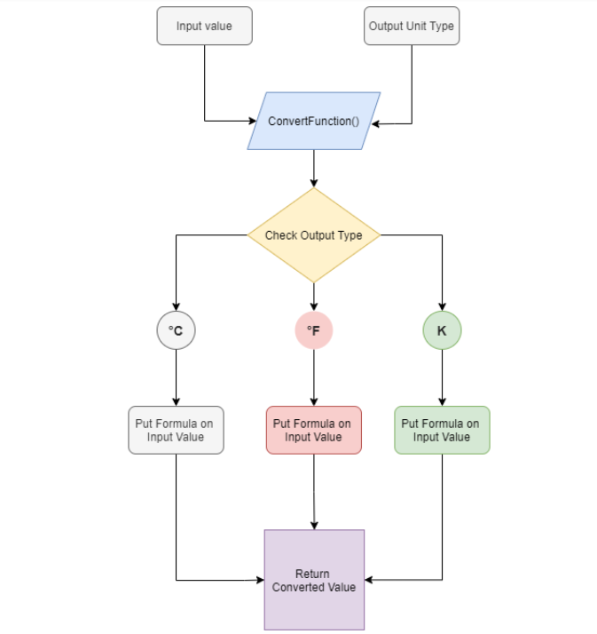

Our function will take two arguments: Input temperature value and output temperature unit type. The function will check the output unit type, apply the formula according to the output temperature unit types and return the converted value.

1. **Fahrenheit Converter ( °F ⇒** °C or K **)**

This function will only convert the Fahrenheit temperature value into Celsius or Kelvin. So whenever the user enters a °F value, we have to call this function. The reference code is shown below: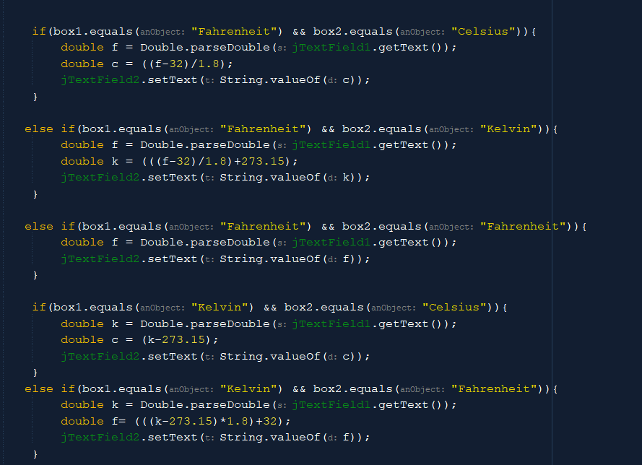

1. **Celsius** **Converter ( °C ⇒** °F or K **)**

This function will only convert the Celsius temperature value into Fahrenheit or Kelvin. So whenever the user enters a °C value, we have to call this function. The reference code is shown below: 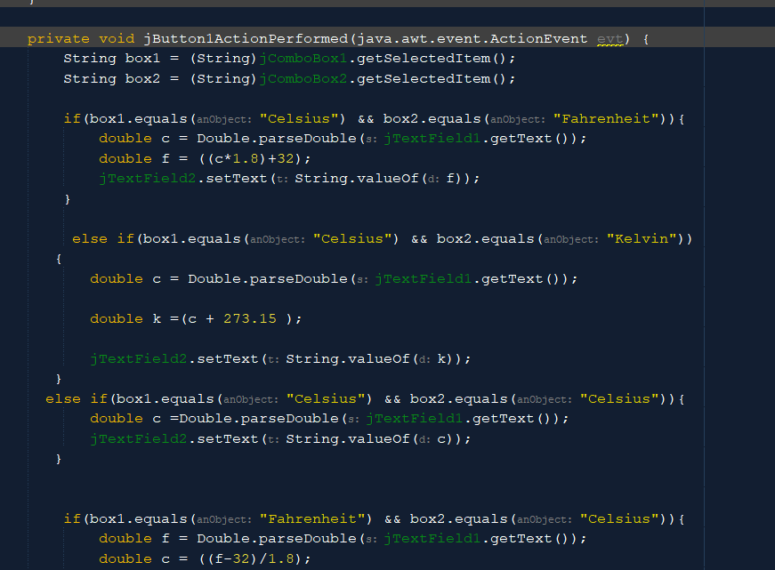

1. **Kelvin** **Converter ( K ⇒** °F or °C **)**

This function will only convert Kelvin temperature value into Fahrenheit or Celsius. When a user enters a K value, we have to call this function. The reference code is shown below:



**Outcome of project**

The outcome of a temperature converter depends on the input temperature and the units of measurement used in the conversion. Generally, temperature converters are used to convert temperatures between different units such as Celsius, Fahrenheit, and Kelvin.

For example, if you input a temperature of 25 degrees Celsius into a temperature converter and select the option to convert it to Fahrenheit, the outcome would be 77 degrees Fahrenheit. Similarly, if you input a temperature of 32 degrees Fahrenheit and select the option to convert it to Celsius, the outcome would be 0 degrees Celsius.

It's important to note that temperature converters use mathematical formulas to convert temperatures between units, so the outcome is typically precise and accurate as long as the correct formula is used and the input temperature is entered correctly.

**Conclusion:**

In conclusion, temperature conversion is an essential concept in science, engineering, and everyday life. It involves converting temperatures from one unit to another, such as from Celsius to Fahrenheit or Kelvin.During this project, we learned how to build a temperature conversion program that can convert temperatures from one unit to another. We also learned about the different temperature units and their conversion formulas, including Celsius, Fahrenheit, Kelvin. We discovered that the conversion formula differs depending on the unit being converted from and the unit being converted to.Overall, this project helped us gain a better understanding of temperature conversion and how it is used in various fields. We also developed our programming skills by building a temperature conversion program from scratch.